Silver Bullet Strategy
Minimum trade framework: For index futures, the minimum trade framework should be 10 points or 40 ticks, while for forex pairs, it should be 15 pips. It is important to note that this framework represents the best-case price delivery that you expect to see, not your actual trade entry to exit range.
- Previous day high or low as draw on liquidity: If the market is bullish, there will be buy stops or buy sell liquidity resting around yesterday's high. This means that we would be looking for a run to the previous day's high. Vice versa if the market is bearish. We would look for potential setups that would expand down into that liquidity.
- Previous weekly high or low as draw on liquidity: If we are bullish, we would look for a run above the previous week's high. For high that has already been rated that morning, it may not be the ideal scenario. So, it might require you to look at a higher timeframe liquidity pool or inefficiency above price if you're bullish.
- Returning to a current or old new week opening gap: This means that the market is returning to a gap that was not filled. This is a good opportunity to look for a potential setup.
- Classic ICT optimal trade entry: This setup is based on the concept of "smart money" and how they move the market. If you can identify the smart money's activity, you can enter the market at an optimal price.
- Fair value gap: This is when the market opens above or below fair value. If the market opens above fair value, it is a good opportunity to look for short setups. If the market opens below fair value, it is a good opportunity to look for long setups.
- Determining the next most likely draw in price action: This is the most important skillset to focus on. All the entries and accents are less important because you don't know where price is trying to go from the time you're sitting and looking at your charts. The main emphasis is determining the next most likely draw in the price action.
Silver Bullet Hour Guide
1. Every day between 10am & 11am EST, identify an obvious pool of liquidity that has not been tapped into or engaged.
2. Wait for displacement towards liquidity pool between that time.
3.Find a FVG (FVG has to be opposite the targeted liquidity pool)
4. Wait for price to trade back into FVG and then reprice out of the FVG towards the targeted pool of liquidity.
5. Then drop down to the 3m, 1m chart and start looking for a second FVG.
6.The next FVG you see on the 3m, 1m chart (after price has traded back into the higher timeframe FVG) instantly enter the trade in the direction of the targeted liquidity pool.
EXAMPLE

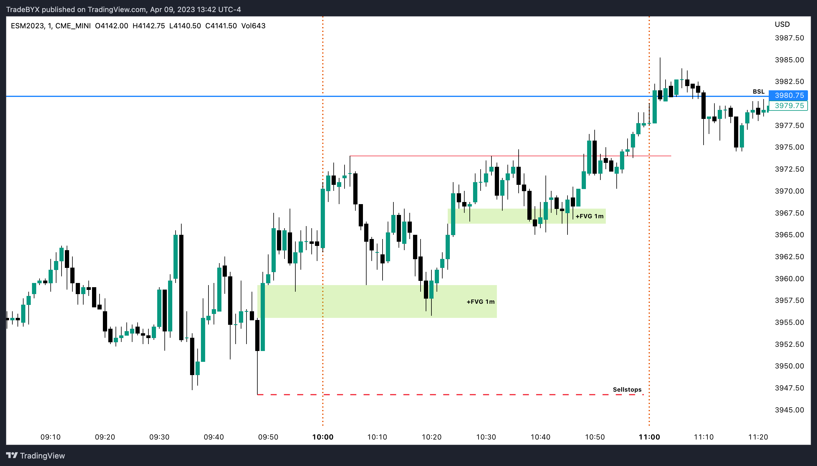

2. The AM Session Silver Bullet (10 AM — 11 AM New York local time)
In the ICT Silver Bullet Trade Setup, the AM Session is focused on the 10 o'clock to 11 o'clock time window. During this time frame, we wait for the market to be bearish/bullish with relative equal lows/highs and sell/buy side resting below/above. This is followed by a fair value gap, which is a bearish/bullish FVG. When the market trades up/down into this gap, we can sell/buy short.
It is important to note that the trade is many times held in duration longer than the window that the framework and entry is derived from. This means that you're looking for the setup to form to get you into the trade within the scope of 10 o'clock to 11 o'clock near local time. Shorting/Long into the FVG and covering at the old low/high allows for at least 5 handles. The key takeaway is to focus on the skill set first and look for high probability trades using the framework.
This strategy demands a deep understanding of the market dynamics and the ability to make swift decisions based on market movements.
- Every day between 10am & 11am EST, identify an obvious pool of liquidity that has not been tapped into or engaged.
- Wait for displacement (use 1-3-5m) towards liquidity pool between that time. Find a FVG (FVG has to be opposite the targeted liquidity pool).
- Wait for price to trade back into FVG and then reprice out of the FVG towards the targeted pool of liquidity.

